**Windows Version**

/*

09/17/2017

Nabir Migadde/Melanie Sou

1648223/1606508

CISP 360 - M/W 1:30pm - 2:50pm

Spring 2017

Assignment #4 Box Office

Display the gross profit and net profit of a movie

*/

#include <iostream>

#include <iomanip>

#include <string>

using namespace std;

//Box Office

int main() {

//Initialization of Variables

string movieNam;

int numAduTic;

int numChiTic;

double gProfit;

double nProfit;

double amouDistri;

//Ask user for information

cout << "Enter the name of the movie: "; // Name of Movie

getline(cin, movieNam);

cout << "Enter the number of adult tickets sold: "; // Number of Adult Tickets

cin >> numAduTic;

cout << "Enter the number of child tickets sold: "; // Number of Child Tickets

cin >> numChiTic;

cout << endl;

//Calculations

gProfit = (10 * numAduTic) + (6 * numChiTic); //Gross Profit

nProfit = .2 * gProfit; // Net Profit

amouDistri = gProfit - nProfit; //Amount Paid to Distributor

//Display the Results to the user

cout << "Revenue Report" << endl;

cout << "==============" << endl;

cout << setprecision(2) << fixed;

cout << "Movie Name:" << setw(18) << '"' << movieNam << '"' << setw(1) << endl;

cout << "Adult Tickets Sold:" << setw(17) << numAduTic << setw(1) <<endl;

cout << "Child Tickets Sold:" << setw(17) << numChiTic << setw(1) <<endl;

cout << "Gross Box Office Profit: $ " << setw(1) << gProfit << endl;

cout << "Net Box Office Profit: $ " << setw(1) <<nProfit << endl;

cout << "Amount Paid to Distributor: $ " << setw(1) <<amouDistri << endl;

system("pause");

return 0;

}

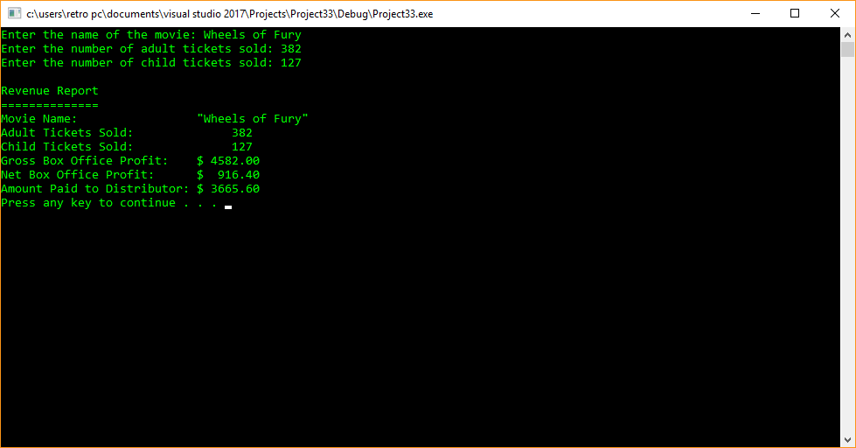

**Linux Version**

/*

09/17/2017

Nabir Migadde/Melanie Sou

1648223/1606508

CISP 360 - M/W 1:30pm - 2:50pm

Spring 2017

Assignment #4 Box Office

Display the gross profit and net profit of a movie

*/

#include <iostream>

#include <iomanip>

#include <string>

using namespace std;

//Box Office

int main() {

//Initialization of Variables

string movieNam;

int numAduTic;

int numChiTic;

double gProfit;

double nProfit;

double amouDistri;

//Ask user for information

cout << "Enter the name of the movie: "; // Name of Movie

getline(cin, movieNam);

cout << "Enter the number of adult tickets sold: "; // Number of Adult Tickets

cin >> numAduTic;

cout << "Enter the number of child tickets sold: "; // Number of Child Tickets

cin >> numChiTic;

cout << endl;

//Calculations

gProfit = (10 * numAduTic) + (6 * numChiTic); //Gross Profit

nProfit = .2 * gProfit; // Net Profit

amouDistri = gProfit - nProfit; //Amount Paid to Distributor

//Display the Results to the user

cout << "Revenue Report" << endl;

cout << "==============" << endl;

cout << setprecision(2) << fixed;

cout << "Movie Name:" << setw(18) << '"' << movieNam << '"' << setw(1) << endl;

cout << "Adult Tickets Sold:" << setw(17) << numAduTic << setw(1) <<endl;

cout << "Child Tickets Sold:" << setw(17) << numChiTic << setw(1) <<endl;

cout << "Gross Box Office Profit: $ " << setw(1) << gProfit << endl;

cout << "Net Box Office Profit: $ " << setw(1) <<nProfit << endl;

cout << "Amount Paid to Distributor: $ " << setw(1) <<amouDistri << endl;

// system("pause");

return 0;

}

